CSE 595 Independent Study

Graph Theory

Week 4

California State University - San Bernardino

Richard Vargas

Supervisor – Dr Owen Murphy

Chapter 3 Problem 1 (Nonseparable Graphs)



Looking at Theorem 3.2 in Chartrand [1] which states,

*A vertex $v$ in a graph $G$ is a cut-vertex of $G$ if and only if there are two vertices $u$ and $w$ distinct from $v$ such that $v$ lies on every $u – w$ path in $G$.*

If a vertex $w$ were to lie further past $v$, then the eccentricity $e(u)≠v$.

Furthermore, if we were to delete $v$ from $G$ and there was another vertex $w$ with the same distance from $u$ then the shortest path $u-w$ does not include $v.∎$

Chapter 3 Problem 7 (Nonseparable Graphs)



1. If a graph has a vertex of degree 1, then this implies the vertex is a leaf. If this vertex is a leaf, then the graph $G-v$ has the same number of connected graphs as $G∎$.
2. If $δ\left(G\right)≥2$, then order of $G≥3$. If this is true, then Theorem 3.3 [1] can be applied which states the following,

Let $G$ be a graph of order 3 of more. Then $G$ is nonseparable if and only if every two vertices of $G$ lie on a common cycle of $G$.

If we follow that there is a cut-vertex of degree 2, then this implies that there are two subgraphs of $G$ connected by the cut-vertex. If the cut-vertex is removed, then we have the two subgraphs. If we remove either adjacent vertex of the cut-vertex, then the cut-vertex becomes a leaf for which ever graph the adjacent vertex belongs to that was not removed $∎$.

1. If we assume that for a graph $G$ of order $n$, that the cut-vertex has a degree of $n-1$, and all other vertices are of degree 1 which are connected to the cut-vertex. This allows for a graph with degree of $k=n-1$ with $k≥2$, which will always create $k$ subgraphs of order 1 $∎$.

Chapter 3 Problem 17 (Nonseparable Graphs)



1. Chapter 3 Problem 1 can be looked in this exercise. A peripheral vertex in a graph $G$ has the largest eccentricity, meaning it has that largest distance from the vertex to another vertex in $G$. Thus, if this is a peripheral vertex, then it follows the earlier above problem and a cut-vertex of $G$ cannot be a peripheral vertex of $G ∎$.
2. This is a false statement. Proving by counterexample, we can examine a graph $G$ with order 1. Although the one vertex in $G$ is a peripheral vertex, it is not a part of an end-block of *G*. In order to be an end-block, the subgraph of $G$ must contain one cut-vertex. A graph of order 1 does not contain any cut-vertex $∎$.

Chapter 3 Problem 19 (Introduction to Trees)

Following Theorem 3.10 [1] which states,

*An edge $e$ in a graph $G$*  *is a bridge of $G$*  *if and only if $e$*  *lies on no cycle in $G$*

Therefore, we know that $e$ does not lie on a cycle in $G$. Since the order is of 3 or more, $deg⁡(u)≥2$ or $\deg\left(v\right)≥2$. At least one of these vertices must therefore have one or more distinct vertices, and therefore is a cut-vertex of $G∎$.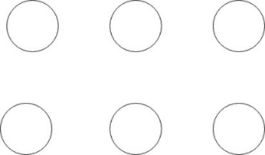Chapter 3 Problem 23 (Introduction to Trees)



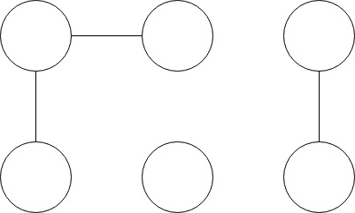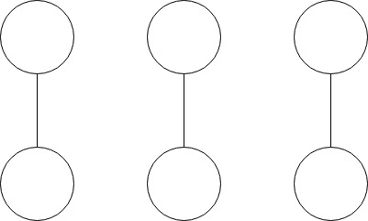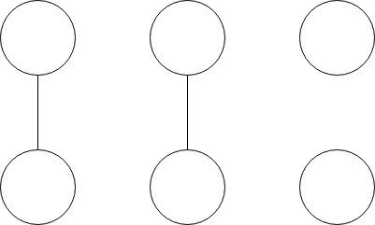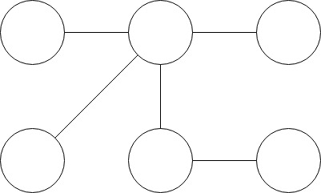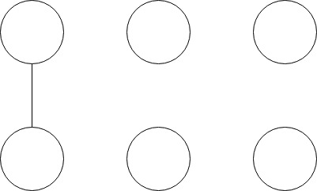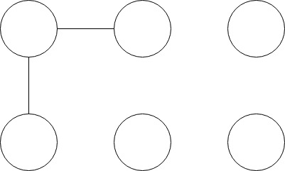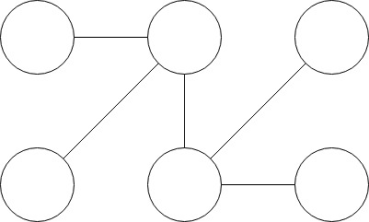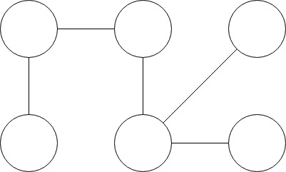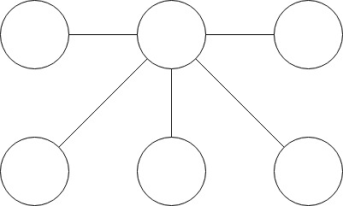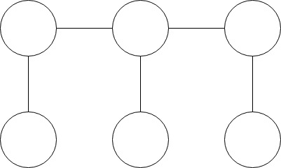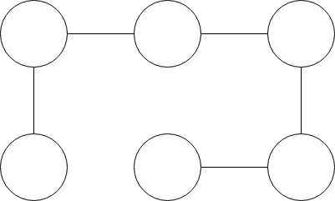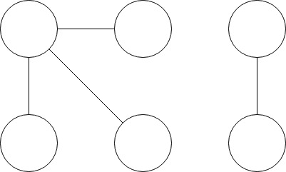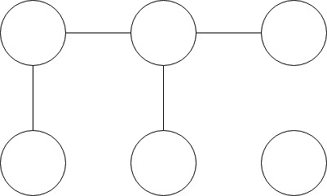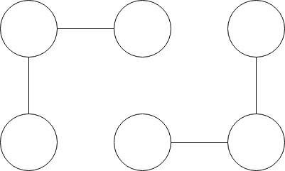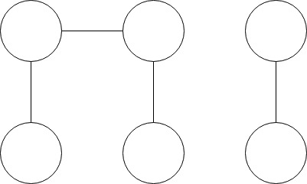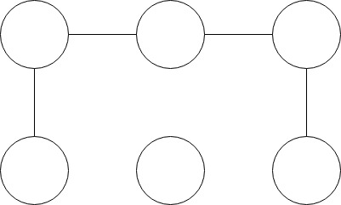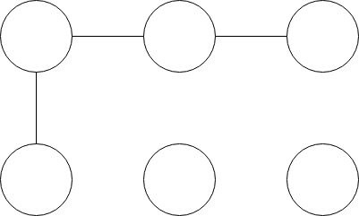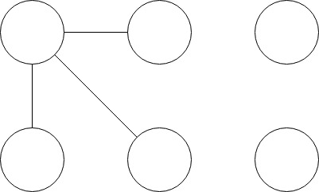

Chapter 3 Problem 29 (Introduction to Trees)



Looking at Theorem 3.9 [1] which states,

*The center of every connected graph $G$*  *lies in a single block of $G$.*

Since the center of a graph $G$ ­ is a vertex $v∈G$ where $\min{e\left(v_{i}\right)}, v_{i}∈G$. There can only be a maximum of two vertices where $\min{e(v_{i})}, v_{i}∈G$ is true in the case of a tree.

Two cases may be looked at then, a tree of order 1, and order 2

Order 1 – If the tree is of order 1, it is just a single vertex. Therefore, the graph $K_{1}$ could be a subgraph of a countably infinite number of supergraphs where cut-vertices have been removed.

Order 2 – If the tree is order 2, there are 2 vertices and one edge connecting them. Similarly to the case above, the $K_{2}$ graph may also be a subgraph of a countably infinite number of supergraphs where cut-vertices have been removed.

All other cases of trees will be separable graphs, who have a center block of either order 1 or order 2 $∎$.

Works cited

“Trees.” *Graphs & Digraphs*, by Gary Chartrand et al., CRC Press, 2016, pp. 57–69.